9.88: a) 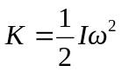
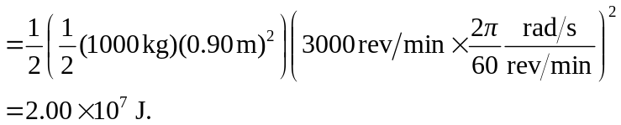
b) 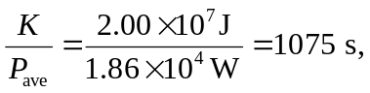
which is about 18 min.

